**1. Write a program in Java for catching Exceptions using class Exception. Define classes ExceptionA(Which inherits from class Exception) and ExceptionB(which inherits from class ExceptionA).In your program, create try blocks that throw exceptions of types Exception, ExceptionB, NullpointerException and IOException. All exceptions should be caught with catch blocks specifying type Exception.**

→

import java.io.*;

class UserDefinedExceptionA extends Exception

{

public UserDefinedExceptionA(String str)

{

super(str);

}

}

class UserDefinedExceptionB extends UserDefinedExceptionA

{

public UserDefinedExceptionB(String str1)

{

super(str1);

}

}

public class Test

{

public static void main(String args[])

{

try

{

throw new IOException("This is an IOException");

}

catch(IOException i)

{

System.out.println("Caught the IO Exception");

System.out.println(i);

}

try

{

throw new UserDefinedExceptionB("This is an user defined exception from Exception B");

}

catch(UserDefinedExceptionB b)

{

System.out.println("Caught the ExceptionB");

System.out.println(b);

}

try

{

String s=null;

System.out.println(s.length());

}

catch(NullPointerException n)

{

System.out.println("This is a NullPointer Exception");

System.out.println(n);

}

}

}

**o/p :**

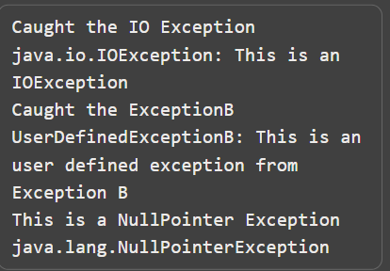

**2. Use inheritance to create an exception superclass(A) and two**

**exception subclasses(B and C),where B inherits form A and C inherits**

**from B. WAP to demonstrate that the catch block for type A catches**

**the exceptions of type B and C.**

→

class ExceptionA extends Exception

{

public ExceptionA(String message)

{

super(message);

}

}

class ExceptionB extends ExceptionA

{

public ExceptionB(String message)

{

super(message);

}

}

class ExceptionC extends ExceptionB

{

public ExceptionC(String message)

{

super(message);

}

}

public class TestExceptions

{

public static void main(String[] args)

{

try

{

throw new ExceptionC("This is an exception of type C");

}

catch (ExceptionA e)

{

System.out.println("Caught an exception of type A");

System.out.println(e.getMessage());

}

}

}

**o/p :**

